FunnishaInsights.com- Episode 3

How Big 4 Consultants Learn to See the Business Behind the Balance Sheet
This episode is intentionally written so that you can begin the series from here. You do not need to read Episodes 1 or 2. Aarav is a newly qualified Chartered Accountant who has just joined the International Tax practice of a Big 4 consulting firm. Like many young professionals, he believes technical tax knowledge is enough to advise multinational companies. Today, he is about to discover that world-class consultants think very differently.
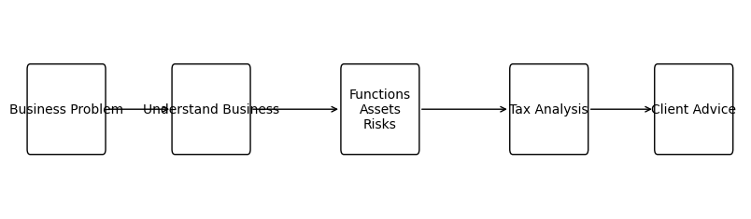
“Every company tells a story. Most accountants read the financial statements. The best consultants read the business.”
It was Wednesday morning. The office buzzed with meetings, laptops, and coffee cups. Partners moved quickly from one client room to another while associates raced to finish presentations.
For Aarav, however, this wasn't just another day. It was the day his understanding of consulting would change forever.
He expected to receive a transfer pricing assignment or a research note on a Double Taxation Avoidance Agreement. Instead, his manager quietly placed a thin blue folder on his desk.
'Forget tax today.'
Inside were no tax provisions, no OECD Guidelines and no case laws. There was only a short profile of GlobalTech Solutions Pvt. Ltd. and one handwritten question:
'Where is value actually created?'
Confidently, Aarav answered: 'The software is developed in India, so the value is created in India.'
Five minutes later, the manager returned, smiled, and asked, 'Are you sure?'
The conversation that followed completely changed Aarav's perspective. Instead of discussing tax, the manager asked:
• Who designed the product?
• Who owns the intellectual property?
• Who funded the research?
• Who decides pricing?
• Who signs customer contracts?
• Who bears the commercial risk?
Aarav realised he had looked at the company the way an accountant looks at financial statements - but not the way a consultant studies a business.
The manager explained that two companies can manufacture the same product and earn similar revenue, yet have completely different international tax consequences because value creation depends on Functions, Assets and Risks- not simply on where work is performed.
Clients never walk into a Big 4 office asking consultants to explain a section of tax law. They come with business decisions: entering a new country, licensing intellectual property, restructuring operations or expanding globally. The consultant's role is to understand the commercial reality first and then determine the tax implications.
That is why the world's best international tax professionals begin every assignment by understanding the business model before opening the Income-tax Act.
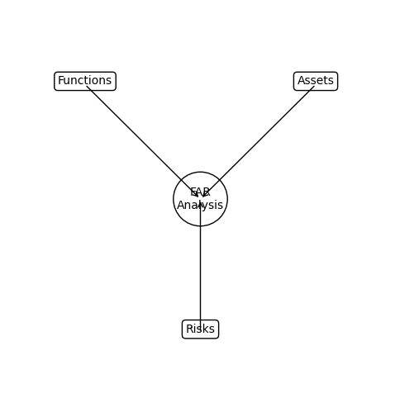

Why FAR Matters
Aarav leaned back in his chair.
His notebook was full—not with tax sections or legal provisions, but with questions. For the first time since joining the International Tax practice, he realised something surprising.
The manager hadn't taught him a single tax law that morning. Yet somehow, he had learned one of the most valuable lessons of his career.
Seeing Aarav's puzzled expression, the manager walked to the whiteboard and wrote three simple words. (Functions, Assets, Risks)
Then he turned around and smiled. "If you can understand these three things, you've already solved half of the international tax problem."
Aarav looked at the board. Three ordinary words. Could they really be that important?
The manager continued.
"Imagine two multinational companies selling the same software around the world. Their revenues are almost identical. Their products look similar. Their customers are the same. But one company earns billions in profits, while the other receives only a routine service fee."
"Why?"
- The answer wasn't hidden in the Income-tax Act.
- Nor was it buried inside the OECD Guidelines.
- It was hidden inside the business itself.
The manager explained that before any consultant analyses transfer pricing, treaty benefits, withholding taxes, or Permanent Establishment issues, they first answer three fundamental questions.

1. Functions – Who Does the Real Work?
- Who develops the product?
- Who negotiates with customers?
- Who makes strategic decisions?
- Who manages the employees?
- Who creates value every single day?

2. Assets – Who Owns What Matters Most?
- Who owns the patents?
- Who owns the software code?
- Who owns the brand?
- Who owns the customer relationships and intellectual property?
Because ownership of valuable assets often determines where profits should be earned.

3. Risks – Who Bears the Consequences?
- Who suffers if the project fails?
- Who absorbs foreign exchange losses?
- Who funds research that may never succeed?
- Who takes responsibility when customers walk away?
The company taking the greatest risks is usually expected to earn a greater share of the rewards.The manager paused for a moment before saying something Aarav would never forget.
"Businesses don't earn profits because they exist. They earn profits because they perform valuable functions, own valuable assets, and assume significant risks."
That... is FAR Analysis.
It is far more than another framework to memorise.It is the lens through which Big 4 consultants understand every multinational business.
It helps them identify where economic value is truly created, which entity deserves the profits, and whether the existing cross-border pricing reflects commercial reality.
Only after understanding these commercial facts do consultants begin analysing transfer pricing, Permanent Establishment exposure, withholding tax obligations, treaty benefits, or any other international tax issue.
Aarav finally understood why his manager had asked him to forget tax that morning. Because great tax advice never starts with tax.
It starts with understanding the business. What Every Future International Tax Consultant Should Remember
- Before you open the Income-tax Act...
- Before you search for an OECD Guideline...
- Before you quote a judicial precedent...
Pause for a moment and ask yourself:
- Who performs the most important functions?
- Who owns the valuable assets?
- Who bears the significant commercial risks?
- Where is the real economic value being created?
- Am I solving a business problem—or merely quoting a tax provision?
The answers to these questions often determine the direction of the entire international tax analysis.That is why the world's leading consulting firms don't simply train professionals to know the law.
They train them to understand businesses first.
And that single shift in thinking transforms an accountant into a trusted advisor.

Coming Up Next…
As Aarav closes his notebook, his manager hands him one final assignment.
"Tomorrow, I don't want a tax opinion."
"I want you to prepare your first FAR Analysis of GlobalTech Solutions."

Aarav has no idea what lies ahead.
But in the next episode, you'll learn the exact FAR framework used by Big 4 consultants to analyse multinational companies—step by step, with practical examples, consulting techniques, and real-world insights that every aspiring international tax professional should master.

